11.80: a) The torque exerted by the cable about the left end is 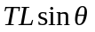. For any angle 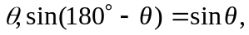 so the tension T will be the same for either angle. The horizontal component of the force that the pivot exerts on the boom will be . b) From the result of part (a), 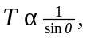and this becomes infinite as 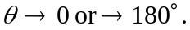 Also, c), the tension is a minimum when 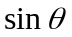 is a maximum, or 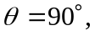 a vertical string. d) There are no other horizontal forces, so for the boom to be in equilibrium, the pivot exerts zero horizontal force on the boom.

